Monday November 24th, 2014
Dear Parents\Guardians,
Christmas is fast approaching and if you’re anything like me, you’re looking into Christmas gifts and stocking stuffers. I am sending you this letter, because this will be the last book orders the students will receive before Christmas break. If you would like to buy a book, a writing set or a game from Scholastic as a present, you can simply send the order with your child in an envelope and write on the front: Christmas Gift with your name and phone number. I’ll keep your order a secret and contact you as soon as the books come in. All book orders will be due on Tuesday December 2nd.
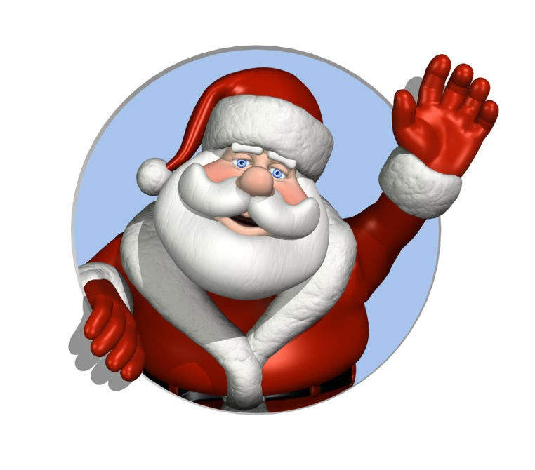
Thank you for your cooperation and Happy Holidays,
Mme Danielle

