Home Learning Lessons for week of April 6 – 10
Literacy: Each day students should be doing 20 minutes of Literacy work. This can include reading on
Raz Kids and sight word games. Kindergarten students should also continue to practice their phonics sounds. Sight Word Games Document can be found at
http://jacquet-river-school.nbed.nb.ca/teacher/mrs-devereau.
Go to https://www.kidsa-z.com/main/Login.
Teachers username is MrsJenniferK1. Click on your child’s name and their password is the picture of the apple.
I have assigned books at your child’s reading level. They can listen to the book be read to them by clicking the icon, read the book independently by clicking the icon and answer comprehension questions by clicking the icon. Each week I will also try to add a few books that relate to the STEAM activity. These are books for them to just listen to. This week those books are: This is a Bird and Let’s Make a Bird Feeder.

Math: Each day students should be doing 20 minutes of Math work. This can include math games on Dreambox and Math card games. Math Card Games Document can be found at
http://jacquet-river-school.nbed.nb.ca/teacher/mrs-devereau
Dreambox is offering 90 days free trial for Math Learning.
You will need to sign up with your email address and create
an account. The nice thing about Dreambox is that as long as students are using it for 30-60mins/week, it will adjust the learning outcomes based on how they are doing.
https://www.dreambox.com/canada
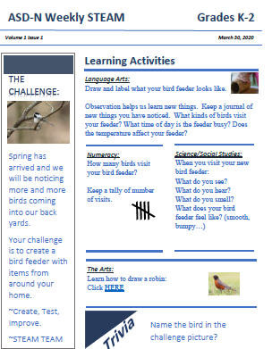
STEAM Activity: Each week the STEAM team will be putting out a challenge that addresses many different Curriculum outcomes (Literacy, Numeracy, YYW and Art).
This weeks Challenge involves a Bird Feeder.
Design & Create: A Bird Feeder from Items around the house.
Literacy: Draw and Label your Bird Feeder. Keep a Journal to document.
Math: Use Tally Marks to keep track of how many birds visit your feeder.
Science: Use your senses to describe your feeder.
Art: Learn how to draw a Robin.
Activity sheet can be reached through the following link:
http://stemnorth.nbed.nb.ca/sites/stemnorth.nbed.nb.ca/files/doc//y2020/Mar/asdn_weekly_steam_issue_1.pdf

