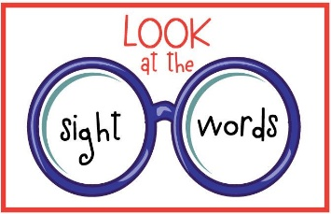 Sight Word Games

**Sight Word Blast**-Write sight words onto small cards or popsicle sticks  
-Write BLAST on a few card/sticks  
-Take turns pulling sticks.  
-Pull stick, read word. If read correctly, you get to keep stick. If incorrect put back.  
-If you pull a BLAST then you need to put all your cards/sticks back.

**Memory Match**-Make 2 copies of all words (or whichever words you are focusing on)  
-Place cards face down on table.  
-Flip card and read word and then flip 2nd card and read.   
-If cards match you keep the pair, if not flip them back over.  
-Player 2 goes.   
-Play continues until no cards remain.

**Sight Word Slap**-Lay sight words out on table or tape to wall or window.  
-Call out a sight word.   
-Have your child find the word and slap it (fly swatter makes it more fun)

*Kindergarten Sight Words*  
a he mom  
am here my  
and I play  
at in see   
can is she   
come it the  
dad like to  
do look we  
go me you

*Grade One Sight Words (plus Kindergarten words)*  
about could if put very   
all day into said was  
an did just so were  
are down little some what  
as for make saw when  
after from man that with  
away get no there would  
be going now they went  
but had not this where  
by have on then who  
back her of them will  
before his one too your  
because has or two  
big him out up  
came how over us