Squiggle Park Literacy
Minimum 10-15 minutes Daily

Access on a Computer/Laptop:
www.squigglepark.com
Click Student Login, Click Play Button
Enter grey image code
Select student name
Enter color image code
Access on Ipad:
https://itunes.apple.com/app/id1077048621
Press orange play button
Enter grey image code
Select student name
Enter color image code
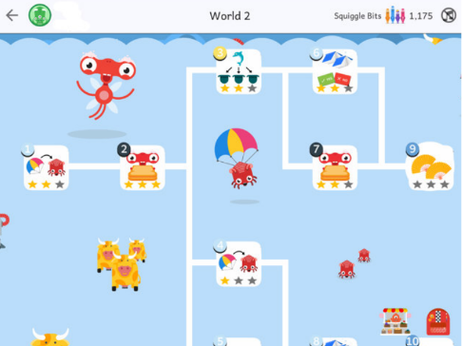
You can explain the concept to your child if they do not understand but then please let them try on their own.
**Please find their login information on the next page.
**When students sign into Squiggle park, I can access their progress and track learning.

